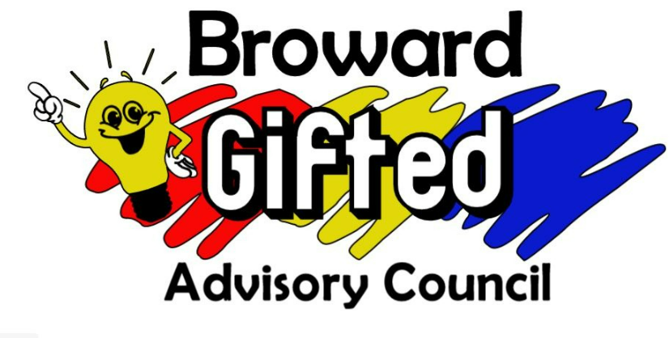

2024/2025 Schedule of Meetings

All in-person meetings will be held at Plantation Middle School located at 6600 West Sunrise Boulevard, Plantation, FL 33313 from 6:30 PM to 8:30 PM.

1. September 9, 2024- In person
2. October 7, 2024- In person
3. November 4, 2024- In person
4. December 9, 2024- In person
5. January 13, 2025- On Teams
   1. To join go to: https://tinyurl.com/GACjan25
6. February 10, 2025- In person
7. March 10, 2025- In person
8. April 14, 2025- In person
9. May 12, 2025- In person

The Broward Gifted Advisory Council (GAC) is a group of parents, volunteers, and educators focused on providing quality gifted education and opportunities for Broward County’s gifted children. We also facilitate two-way communication between parents and the Broward County School District.

Email: [BrowardCountyGAC@gmail.com](mailto:BrowardCountyGAC@gmail.com)

Website: <http://giftedadvisorycouncil.ch2v.com/>